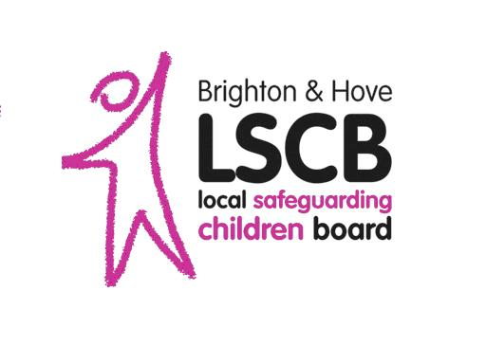
Referral to Brighton & Hove LSCB
of a Serious Incident for Consideration
by the Case Review Subcommittee

Section 1
Section 1 to be completed by the referring officer following a discussion with their line manager and Designated Child Protection professional, and where appropriate, the Case Review Panel member from their organisation. For organisations without a Case Review Panel representative, cases can be discussed with the Head of Safeguarding for the Local Authority.

Please send this form securely to LSCBcasereviews@brighton-hove.gcsx.gov.uk

The objective of this form is to convey as much information that is readily available at the time of completion. If information is unavailable do not delay in making this referral.

1. NOTIFIER DETAILS
Notifying professional: |  | Role (in relation to child):
Date of notification: |  | Contact details:
Who are you submitting this referral on behalf of? (please tick) | An agency |  | A multi-agency partnership  (e.g. CDOP)
 | Please state: |  | Please state:
Signed:

2. CHILD’S DETAILS
Child’s full name: |  |  |  | Other names used:
Child’s date of birth: |  |  |  | Date of death /serious incident:
Gender: |  |  |  | Ethnicity:
Child’s home address:
Where does the child live?  (please tick) | Home |  | Local authority care |  |  | With relatives |  |  | Other (please state)
Child’s educational establishment:

3. PARENTS DETAILS (and other significant adults)
Mother’s name: |  | Mother’s date of birth:
Mother’s address (if different):
Father’s name: |  | Father’s date of birth:
Father’s address (if different):
Details of any other significant adults and their relationship to the child:

4. DETAILS OF SIBLINGS
Name of sibling: | Date of birth: | Gender: | Address (if different to key child):

5. REASON FOR REFERRAL (please tick all appropriate options)
See guidance document for glossary of terms
Considered to meet the Serious Case Review criteria (as set out in Working Together to Safeguard Children 2015)
Child has died and abuse or neglect is known or suspected to be a factor

Child has been seriously harmed (e.g. a potentially life threatening injury, serious sexual abuse) and abuse or neglect is known or suspected to be a factor
There are concerns about the way that agencies have worked together to safeguard the child
The case provides opportunities for learning lessons from multi-agency work

Child has committed suicide

Child has been a perpetrator of a serious crime

6. CASE OUTLINE
Please give a brief summary of the events leading to the referral including any critical incident, key dates, status of child, details of any disability or communication issues and any other relevant information.

7. PARTICULAR CONSIDERATIONS
Please specify any considerations for this case, for example media interest or criminal considerations or other linked cases.
If the case is known to be subject to a criminal investigation please state the lead investigator.
If the case is known to be the subject of a Coroner’s Enquiry please state key contact.

8. ANY OTHER RELEVANT INFORMATION OR ISSUES

9. OTHER AGENCY INVOLVEMENT
Agency: | Name and role of key worker (in relation to key child): | Contact details | Reason for involvement:

10. AUTHORISATION FOR REFERRAL
This form should be countersigned by the manager/professional with whom this referral was discussed.
Name: |  | Role:
Signature: |  | Date:
Contact details:

The Case Review Subcommittee usually meets monthly. Once considered by the subcommittee the referrer and authorising manager/professional will be notified of the outcome in writing by the Case Review Subcommittee Chair.

Section 2
Section 2 to be completed by the Case Review Subcommittee.

1. MEETING
Date of Meeting:
Attendees
Documents considered

2. RECOMMENDATION FOR TYPE OF REVIEW
Please state whether a review is/not recommended and, where applicable what type of review is being recommended (e.g. serious case review or other learning review, multi-agency partnership review or single agency review)
Please state the reasons for the panel decision.

3. RECOMMENDED METHODOLOGY
Please state methodology the case review subcommittee think would be most appropriate and proportional for this review, (ie full SCIE, themed review, IMRs or a systems based hybrid approach). Have any potential lead reviewers been identified?
Estimated cost

4. AUTHORISATION FOR RECOMMENDATION
This form should be signed by the Chair of the Case Review Subcommittee
Name: |  | Role:
Signature: |  | Date:

Section 3
Section 3 to be completed by the Independent Chair of Brighton & Hove LSCB

1. DECISION ON TYPE OF REVIEW
Please state the conclusion you have reached on whether an SCR or other learning review should take place, including the reasons for that decision.

2. ISSUES TO BE CONSIDERED
Please state any particular issues you think must be considered by the review

3. METHODOLOGY
Please confirm if you agree with the suggested methodology and accept the cost implications or comment on another type of methodology that you would like for this review.

4. SIGNED BY INDEPENDENT LSCB CHAIR
Name: |  | Role:
Signature: |  | Date:

If the decision is made to conduct a Serious Case Review the LSCB Manger will notify Ofsted and the national panel of independent experts.

